**Purpose**

This protocol applies to any pediatric tumor from any site or assigned to any specialty, *not just IP*. If the tissue is limited, please ask the surgeon to obtain more tissue if possible. All pediatric surgeons are aware of these requirements. *Our ultimate goal is to establish a diagnosis, so most of the tissue should be fixed for routine processing.*

Initial handling: Between the hours of 8am-5pm, the PA assigned to Mott or pediatric resident is responsible for performing the pediatric tumor protocol. After hours, the resident on AP call is responsible for handling the pediatric tumor protocols.

**Materials**

* 1 cytogenetics conical containing media for chromosome analysis and 1 empty medium snap tube for possible cytogenetics microarray **(Pediatric Tumor Protocol and Lymphoma Workup)**
* 1-6 small snap tubes for freezing tissue (**Pediatric Tumor Protocol and Lymphoma Workup)**
* 1 medium snap tube containing RPMI flow cytometry media **(Lymphoma Workup only)**
* AZF (Acetic Zinc Formalin) fixative and empty container if needed **(Lymphoma Workup only)**
* 6 hand labeled glass slides with accession number, part and air or alcohol: 3 for air dry and 3 for alcohol fixative. 100% ethyl alcohol **(Lymphoma Workup only)**
* Appropriate amount of pre-printed specimen and requisition labels for procedure.
* Liquid nitrogen and dewar.

**Procedure**

**Biopsies:**

* Photograph the specimen received.
* Sample specimen per the *specimen collection procedure* as described below, avoiding areas of necrosis whenever possible.
* Place the remaining specimen in formalin for fixation.

**Resections:**

* Weigh and measure the specimen.
* Photograph the uncut, uninked specimen.
* Ink all margins, or at least where you will be cutting.
* Bisect the specimen and take photographs of the cut surface.
* Document any specific findings such as capsular invasion, necrosis, etc.
* Sample specimen per the *specimen collection procedure* as described below, avoiding areas of necrosis whenever possible.
* Place the remaining specimen in formalin for fixation.

**Specimen Collection Procedure:**

Pediatric Tumor Protocol Kits and Lymphoma Workup Kits are located in the Mott refrigerator on the third shelf.  If no kits are prepared, cytogenetic media and RPMI are located on the first shelf of the refrigerator (see top two pictures below).  Both the small and medium snap tubes are in the storage shelf underneath the scales (see bottom picture below).

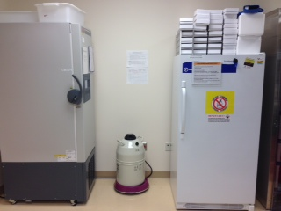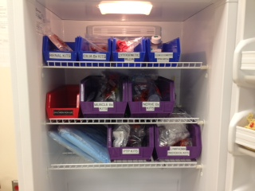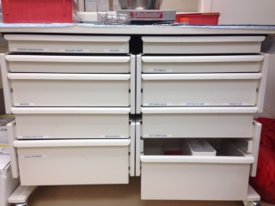

**\*\*\*Priority is for routine HE diagnosis, so please sample judiciously based on the**

**amount of tissue received.**

**Submitting Tissue for Cytogenetics:**

* Take 1 conical of cytogentics media and pour a small amount into a medium snap tube until 1/3 full. The media remaining in the conical will be for standard “chromosome analysis” and the medium snap tube will be for possible “cancer cytogenetics microarray”. Label both the conical and medium snap tube with the pre-printed specimen labels. Take two small tissue samples (roughly 0.2 x 0.2 cm) and place one tissue sample in each tube. (see pictures below)

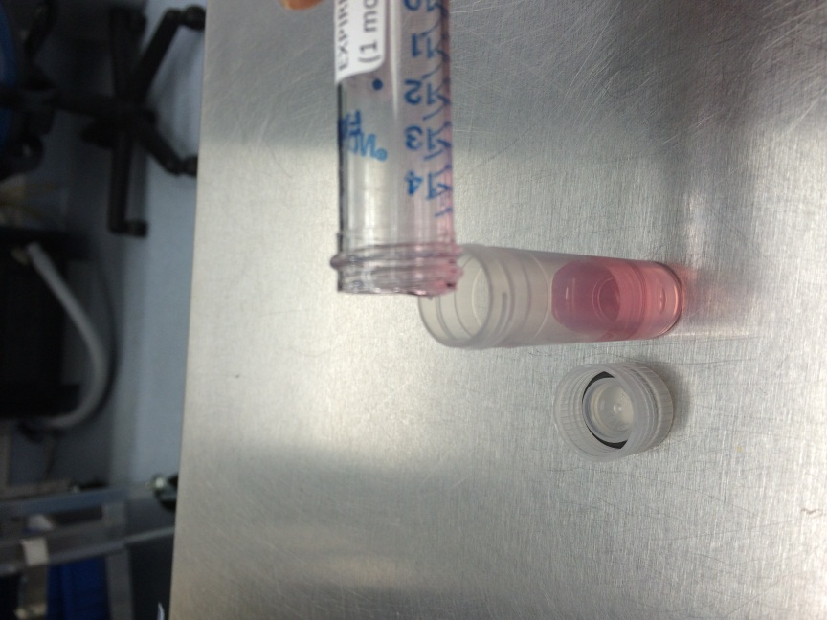 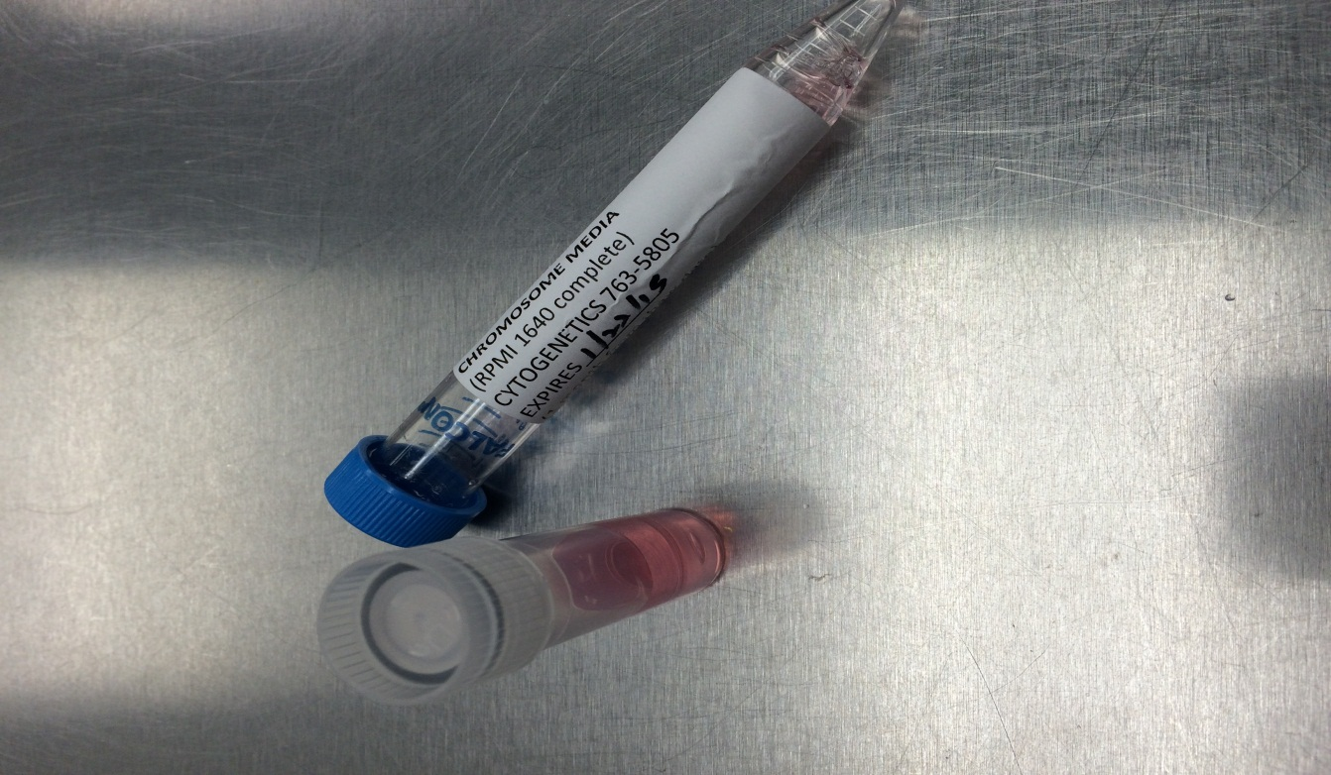

* Cytogenetics requisitions are located in the fridge, next to the PTP kit.   Place a pre-printed requisition label in the top right corner. In the Constitutional/Genetics box, write **“CGNTU” for tumors and “CGNLN” for lymphoma**. Both “Chromosome Analysis” and “Cancer Cytogenetic Microarray” (if sent) are checked in Tests Requested for Malignancy section (see pictures below).

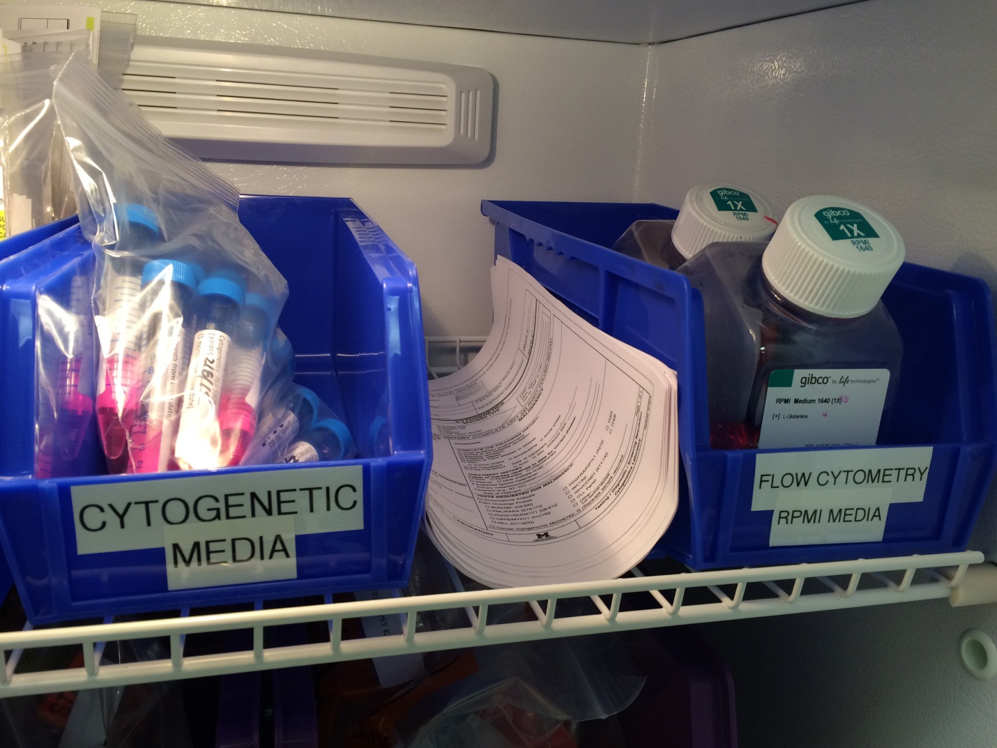

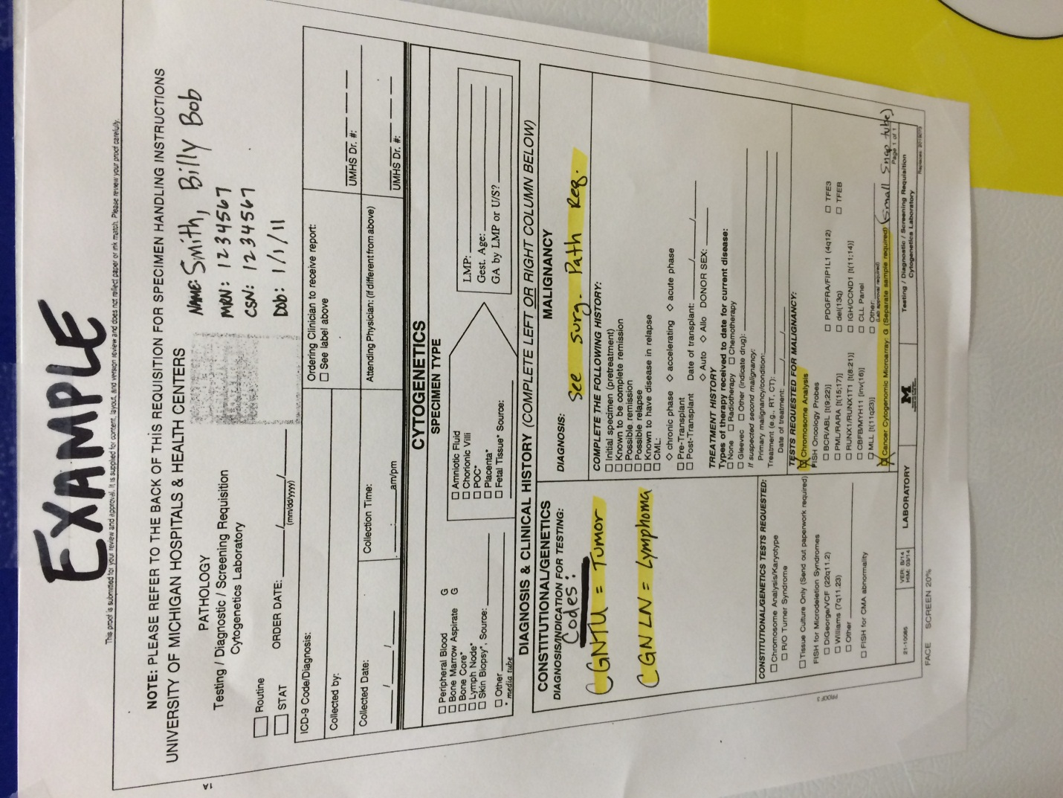

* Make a copy of the surgical pathology requisition.
* Submit microarray tube only if you know for certain there is a definite diagnosis/malignancy (i.e. frozen section or gross evidence). If you’re uncertain of diagnosis, place medium snap tube for “cancer cytogenetics microarray” on shelf in fridge labeled “pending cytogenetcs/microarray” (see picture below). Consult with the pathologist as to what actions need to be taken for the pending tissue. **Note: Tissue should sit no longer than 3 days.**

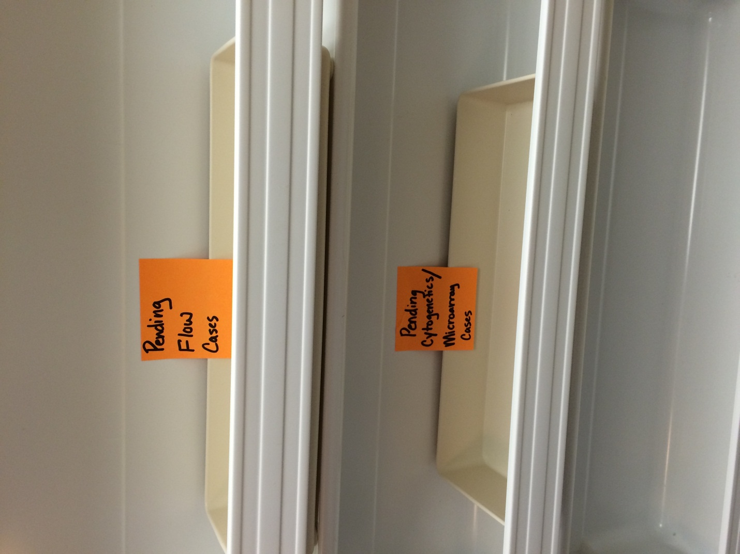

* Cytogenetic tubes, cytogenetics requisition and a copy of surgical requisition are to be properly labeled, packaged in a biohazard bag and transported by the resident directly to central processing if after hours. If during working hours of 8am-5pm, place in fridge until the first person is able to transport to central processing.

**Snap Frozen Tissue at -80**:

* Most of the COG protocols ask for 1 gram of frozen tissue but any amount is acceptable when dealing with small biopsies.
* Generally, freeze a minimum of 1 to 6 samples depending on the amount of tissue received. If small core biopsies, ½ core is sufficient. If large tumor, at least 6 samples are preferred.
* Small samples of tissue (roughly 0.2 x 0.2 cm or core biopsies) are placed individually in small, snap frozen tubes that are labeled with specimen labels (see picture below)

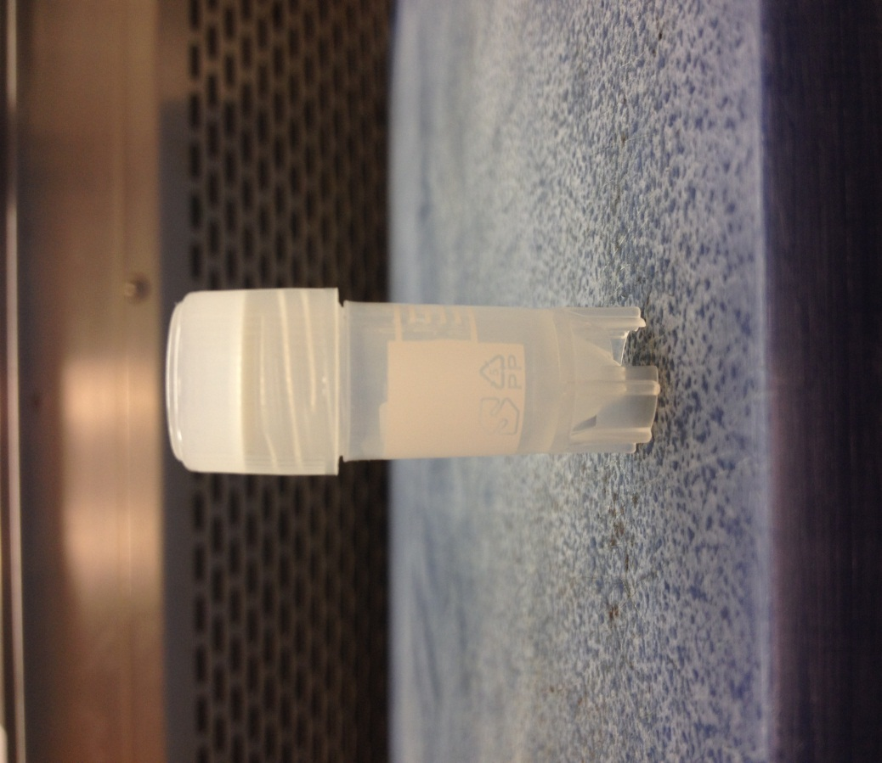

* The liquid nitrogen storage container is located between the -80 freezer and the refrigerator (see pictures below). Pour liquid nitrogen into the metal container labeled “Reserve Dewar” located on the grossing station across from the main accessioning computer. Tubes are to be immediately snap frozen in liquid nitrogen for 30 seconds. (see pictures below).

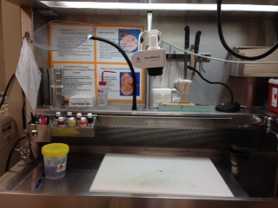

* After freezing specimens, locate the -80 freezer next to the refrigerator. Place snap tubes in the most recent white snap tube box (see picture below).

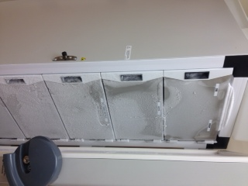

* All specimens placed in the -80 freezer must be logged in the Pediatric Tumor Protocol Specimen book located on the shelf above the main accessioning computer. Place a requisition label in the book and indicate the required information (see pictures below).

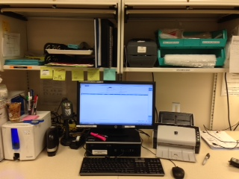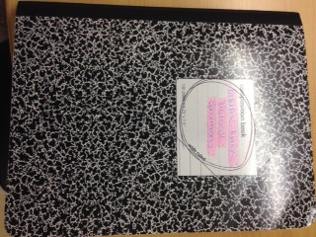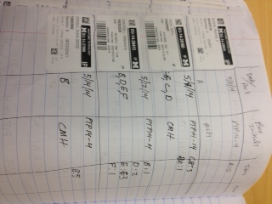

**For Lymphoma Workup**:

* Submit an additional small sample in a medium snap tube in RPMI.  RPMI can be found in the fridge next to the cytogenetics media. Label tube with pre-printed specimen label. Make a copy of the surgical pathology requisition and write “tissue for flow cytometry” anywhere on the requisition. Package the RPMI tube and copy of surgical requisition in a biohazard bag. Write “flow” on the biohazard bag with permanent ink. The sample needs to be transported by the resident directly to central processing if after hours. If during working hours of 8am-5pm, place in fridge until the first person is able to transport to central processing
* Prepare touch prep slides, 6 in total: 3 for 100% ethyl alcohol fixation and 3 for air dry. Write the accession number, part and alcohol or air on the slides with permanent ink. Gently touch the tissue to the slides making a smear. Place the alcohol slides in 100% ethyl alcohol for 5-10 minutes. Place all the unstained slides in a meat try and file with the surgical requisitions located above the accessioning computer (see picture below). **Note: Do not perform touch preps with small tissue cores.**

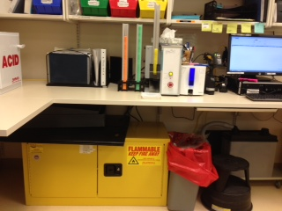

* Also submit an additional permanent section fixed in AZF for at least 2 hours. AZF is located in the yellow flammable cabinet underneath the main accessioning station (see pictures below). Once fixation in AZF is complete, place cassette with all other cassettes in red formalin bin. AZF has a separate waste container.

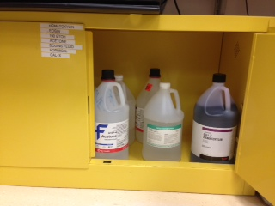

**Pediatric Renal Tumors**:

Pediatric renal tumors have several additional requirements.  Snap frozen tissue and cytogenetics should be performed on *tumor, normal kidney and any metastatic focus* for LOH studies.  Please refer to the Pediatric Renal Tumor protocol regarding proper grossing methods for these specimens.

**Additional Information**:

Make sure to notify the resident/fellow/pathology assistant responsible for grossing the pediatric specimen.  You may also want to check with the faculty to see if they would like any sections submitted for rush processing, unstained slides or immunohistochemical studies.

**Flowchart**

